Welcome to the new EstateSale-Finder.com!
In this tutorial, we’re going to post a sale.
From the new homepage, navigate to the upper right hand corner, and click on ‘List a Sale/Business.’
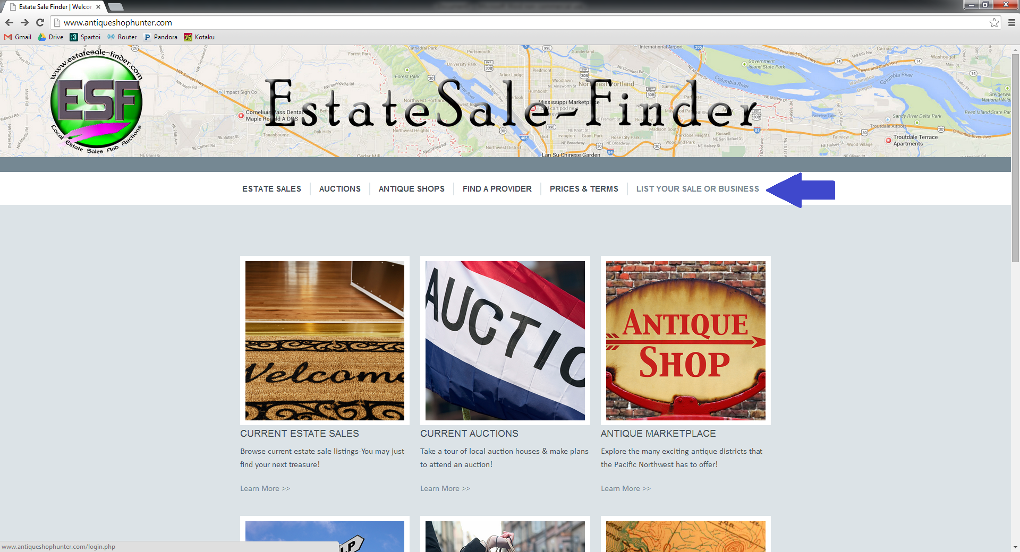

If you are an existing ESF customer, the first time you log in you will need to select the ‘Forgot Username or Password’ option. We have already established accounts for our current users, and at this point you’ll be customizing your password. You’ll only need to do this the first time you use the new ESF site-to access your account on any subsequent visits, just enter your username and password and click ‘Login’ to be redirected to your account homepage.
If you are a new ESF customer, use the ‘Create Account’ button on the right side of your screen.
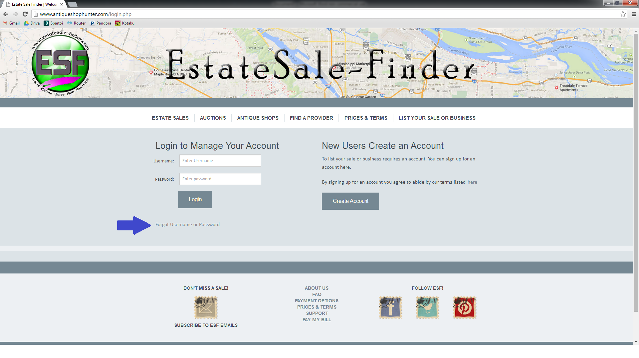

Clicking on “Forgot Username or Password” will bring up a pop-up window, prompting you to enter your email address. Do so, and click ‘Submit.’
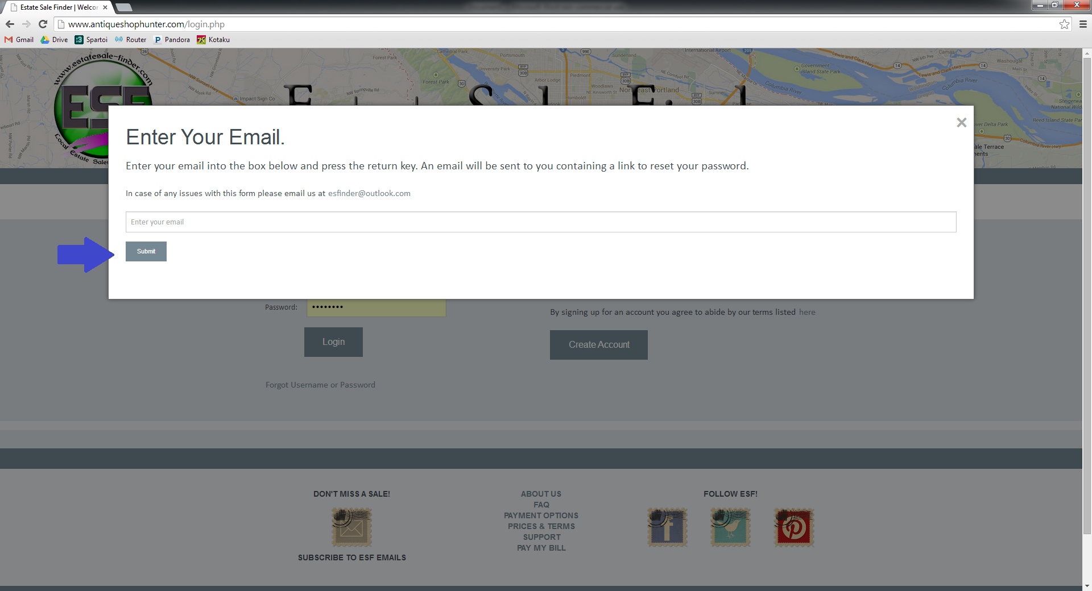

You will receive an email from EstateSale-Finder.com that will provide you with a temporary link in order to reset your password.
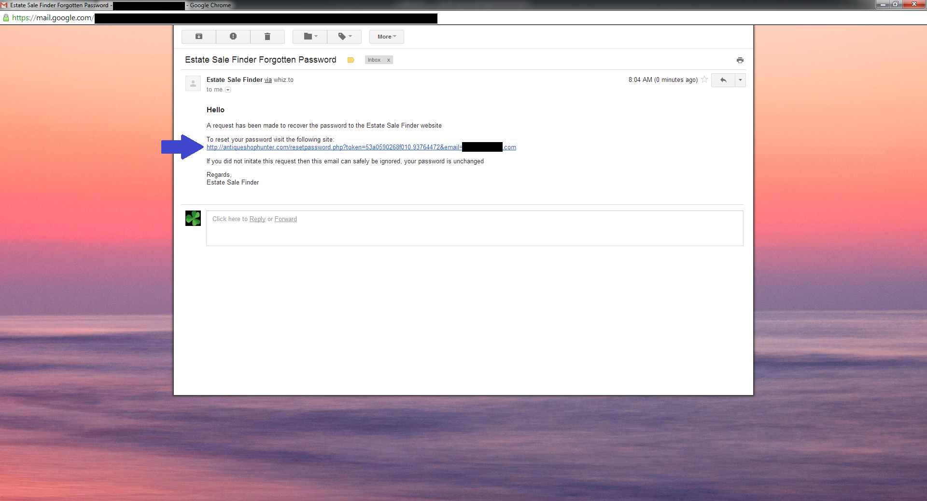

The link will bring you back to EstateSale-Finder. At this time, you may select your password and type it into the ‘Password’ box. Next, click ‘Save.’
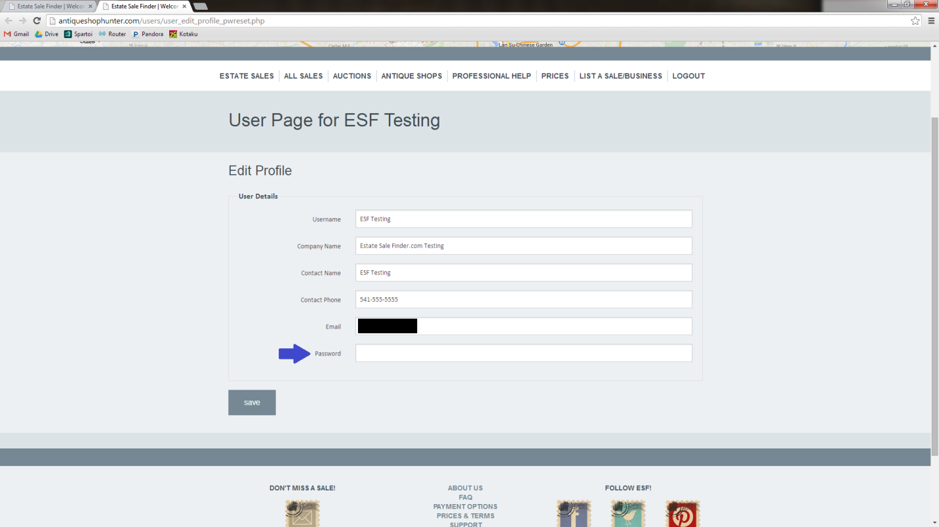

Once you have your password reset, you’ll be allowed to login, and you’ll be redirected to your account-specific homepage. This page allows you to view recent transactions, your account balance, your current and upcoming sales, and provides a ‘Make a Paypal Payment’ button, allowing you to pay your account balance instantly.
You’ll notice that for this particular account, there is already a $50.00 balance. 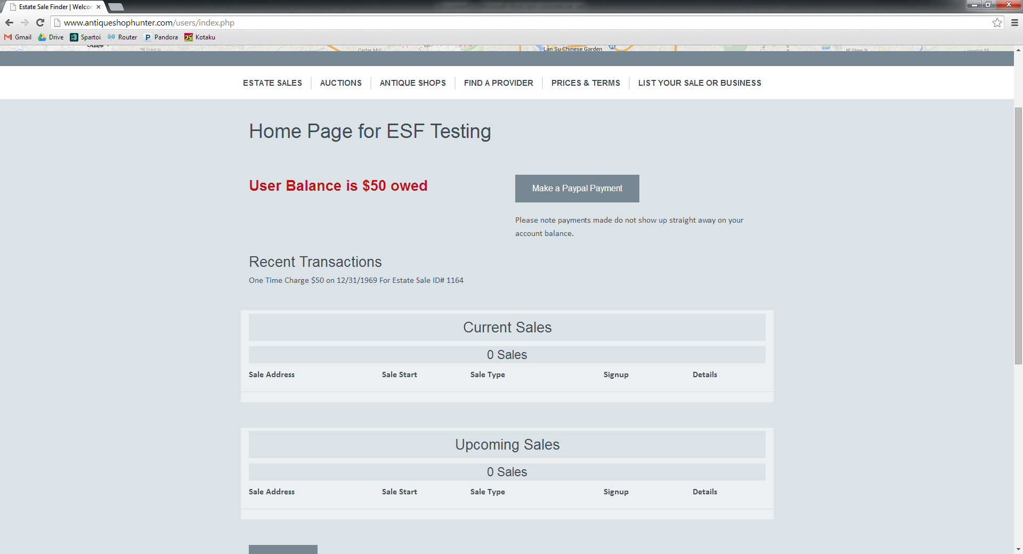

For the purpose of this tutorial, we’ll scroll down to the bottom of this page and select ‘Add a Sale.’
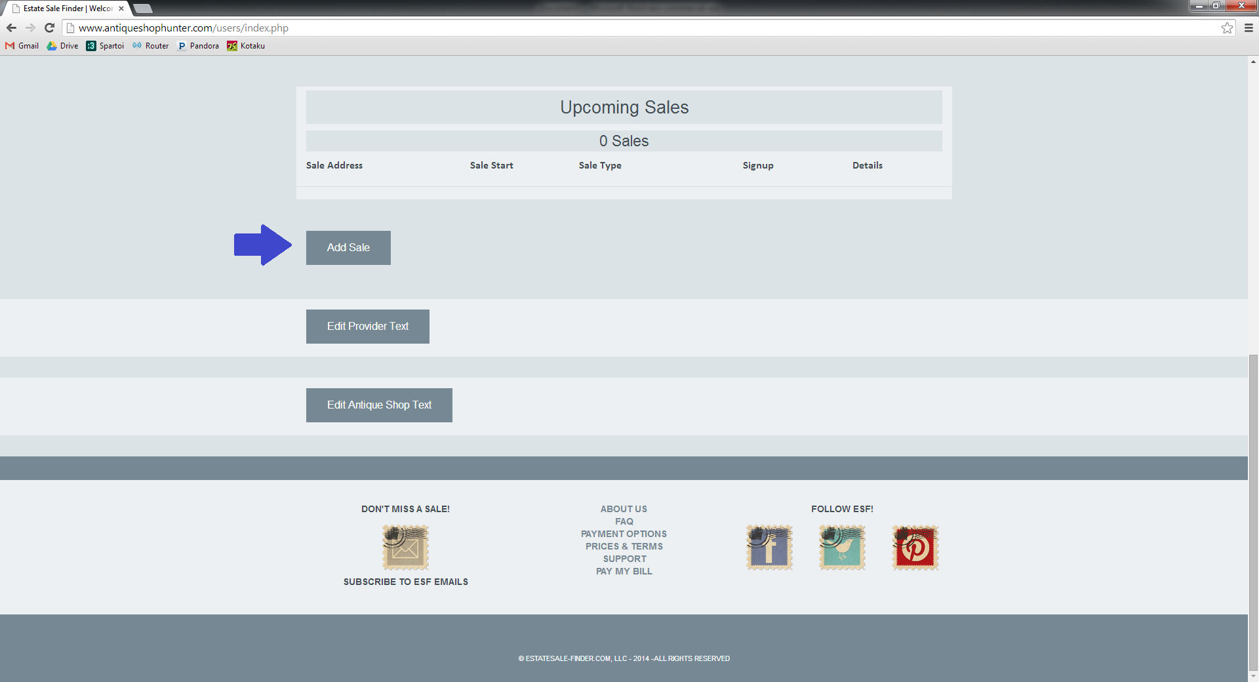

You’ll be redirected to the form to add your sale. You’ll notice that the first part of the form is the sale location. Simply enter your COMPLETE sale address, regardless of when you want it posted. Please note that this step requires you to enter the address in its entirety- street number, city, state, and zip. In the next few steps, there will be an option to schedule the range of time that your address will be displayed on ESF.
If you have any special driving or parking instructions, you can add them to the ‘Special Driving or Parking Instructions’ text box.

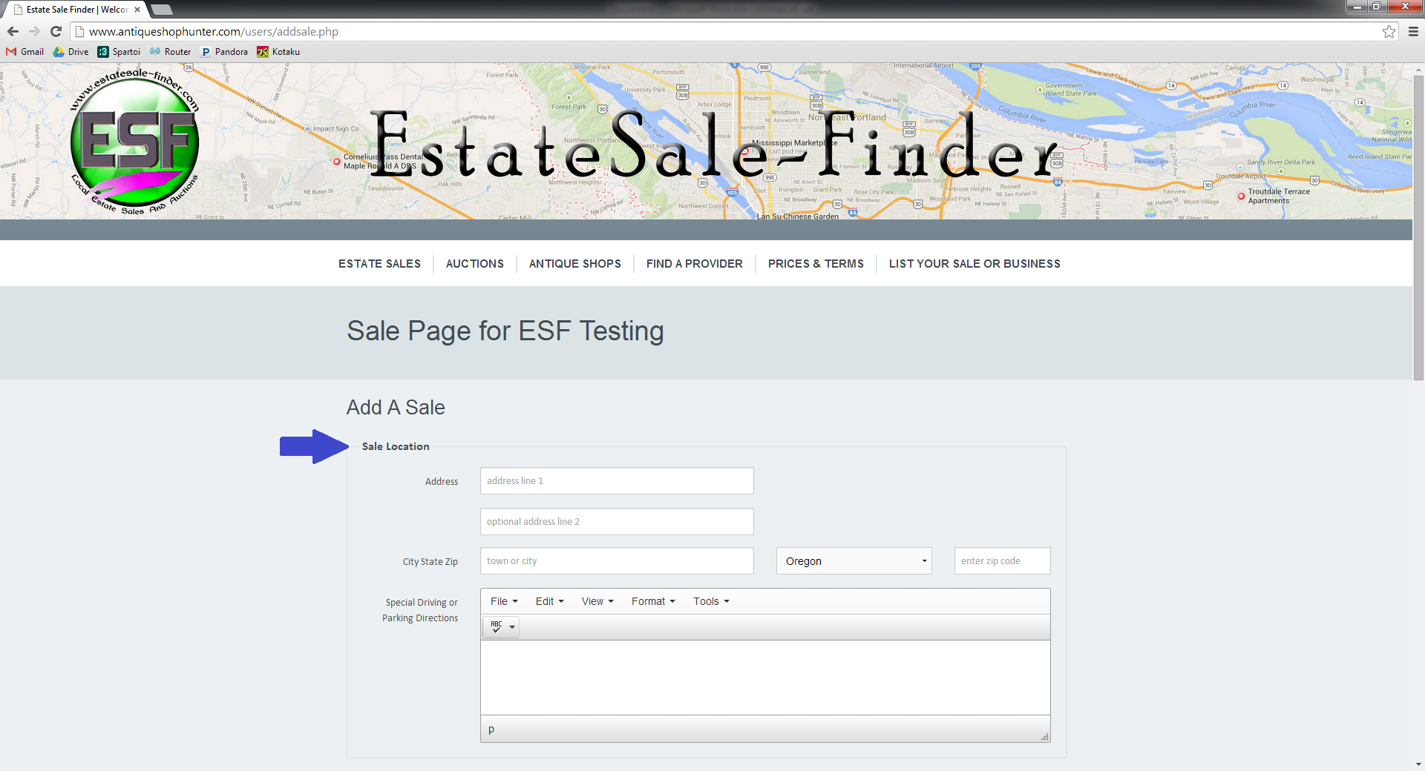

The next section that you will complete is the Sale Details.
The first part of this section asks you for the date and start time for the BEGINNING of the sale, and then the date and end time for the END of the sale. This allows the site to capture the date/time range that your sale spans, allowing the sale and address to be displayed correctly.
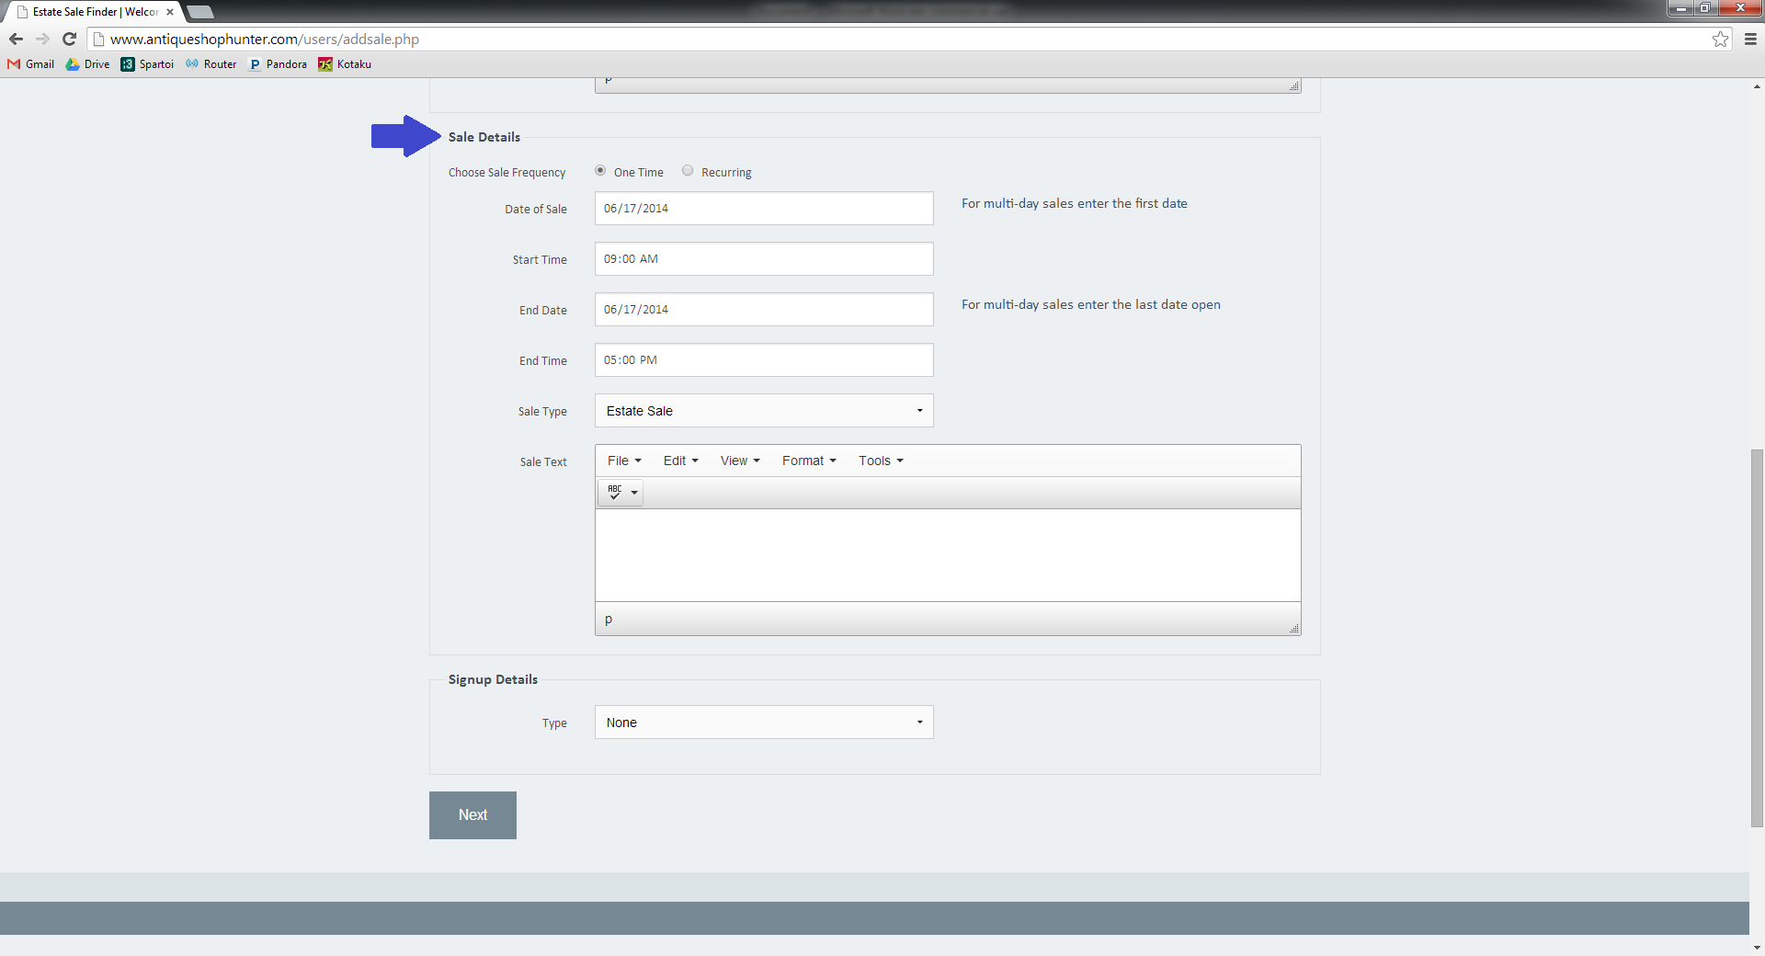

For example, if your sale is Saturday, June 21st from 9-4 and Sunday, June 22nd 12-5, your:
‘Date of Sale’ is 6-21-2014
‘Start Time’ is 9:00 AM
‘End Date’ is 6/22/2014
‘End Time’ is 5:00 PM
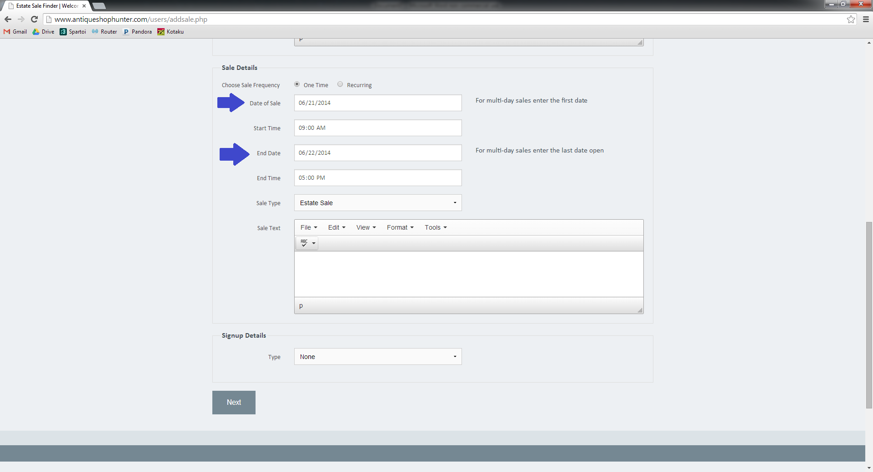

Once you’ve entered the start and end date, the site will detect if you are having a single or multi-day sale. When you have a sale that is longer than one day, the ‘Multiday Text’ box will populate. This is where you’ll add each day/sale hours as free text.
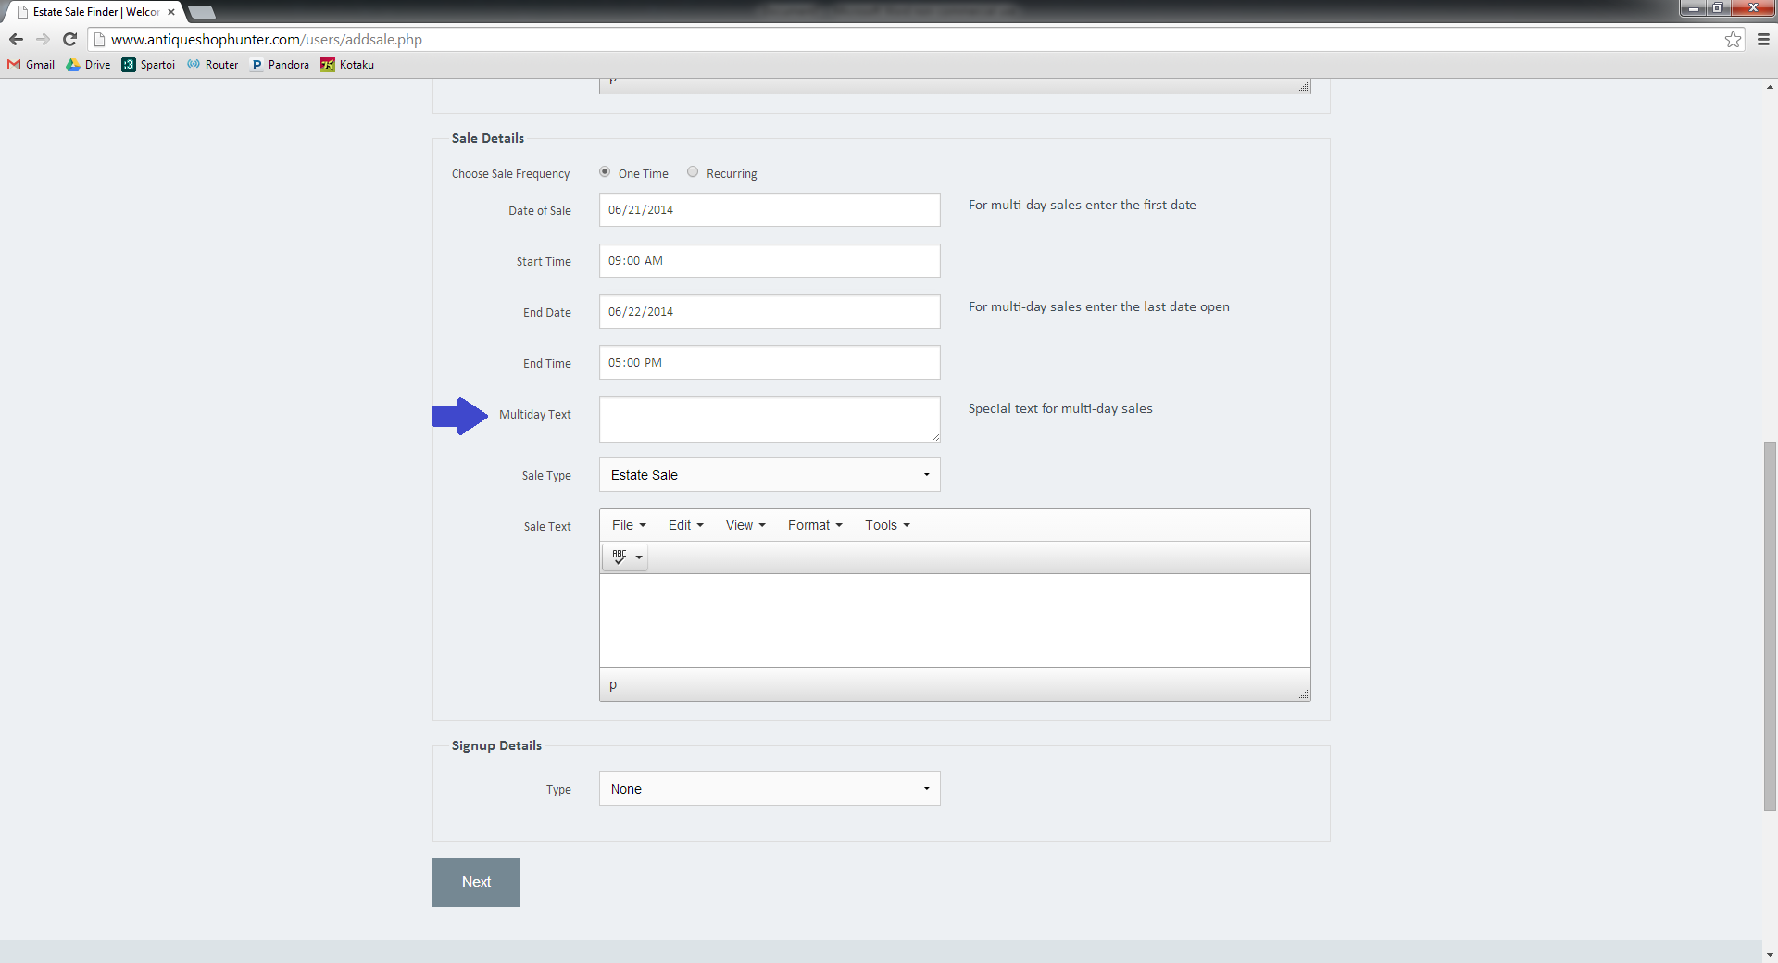

For example, Saturday 9-4 and Sunday 10-3. The information that you enter in this text box will be displayed to your shoppers, so we recommend that you use proper capitalization and punctuation. There is also a spellcheck feature provided for your convenience.
The next step asks you for your sale type. By clicking on the arrow located in the right side of the dropdown box, you can select the type that best describes your sale.
The last part of this section is your sale text. This is where you’ll enter the description of your sale. Again, the information that you enter in this text box will be displayed to your shoppers, so we recommend that you use proper capitalization and punctuation. There is also a spellcheck feature provided for your convenience.
If you have a signup for your sale, use the drop down box in the ‘Signup Details’ section to select the appropriate type. This will when activate the ‘Details’ text box. This is where you may enter additional information such as a phone number, time available, or specific list instructions.
Once you’ve entered all your information, click the next button.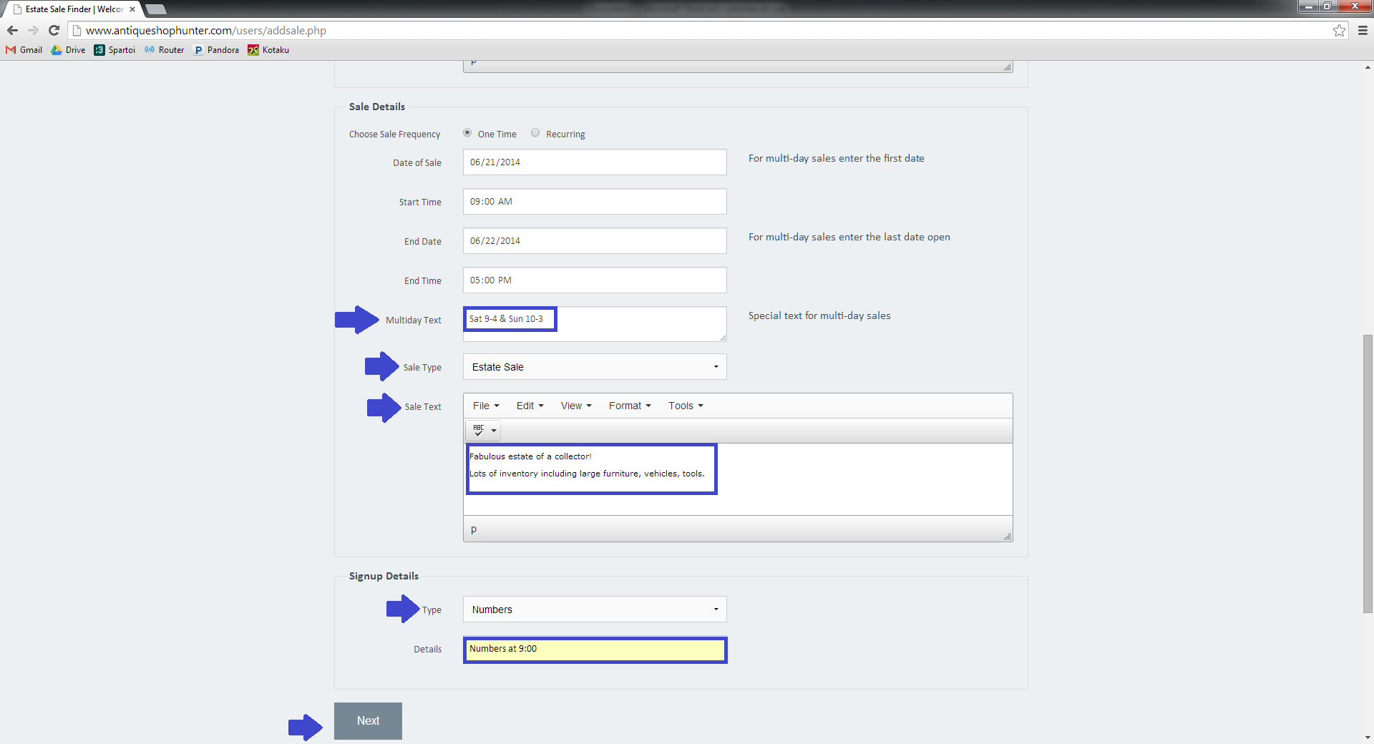
This takes you to the Sale Display Time option. As mentioned previously, you now have the ability to schedule when your sale address appears and is removed from ESF. The default for displaying the address is 24 hours prior to your sale start, with removal at the conclusion of the sale. If you would like to change these settings, use the ‘Posting Details’ section.
You can see that you’ll be asked to enter the start date, start time, end date, and end time for displaying your address. Your sale will be viewable regardless of when you request the address to be posted. Until the address is released, it will display as ‘TBA’ to your shoppers.
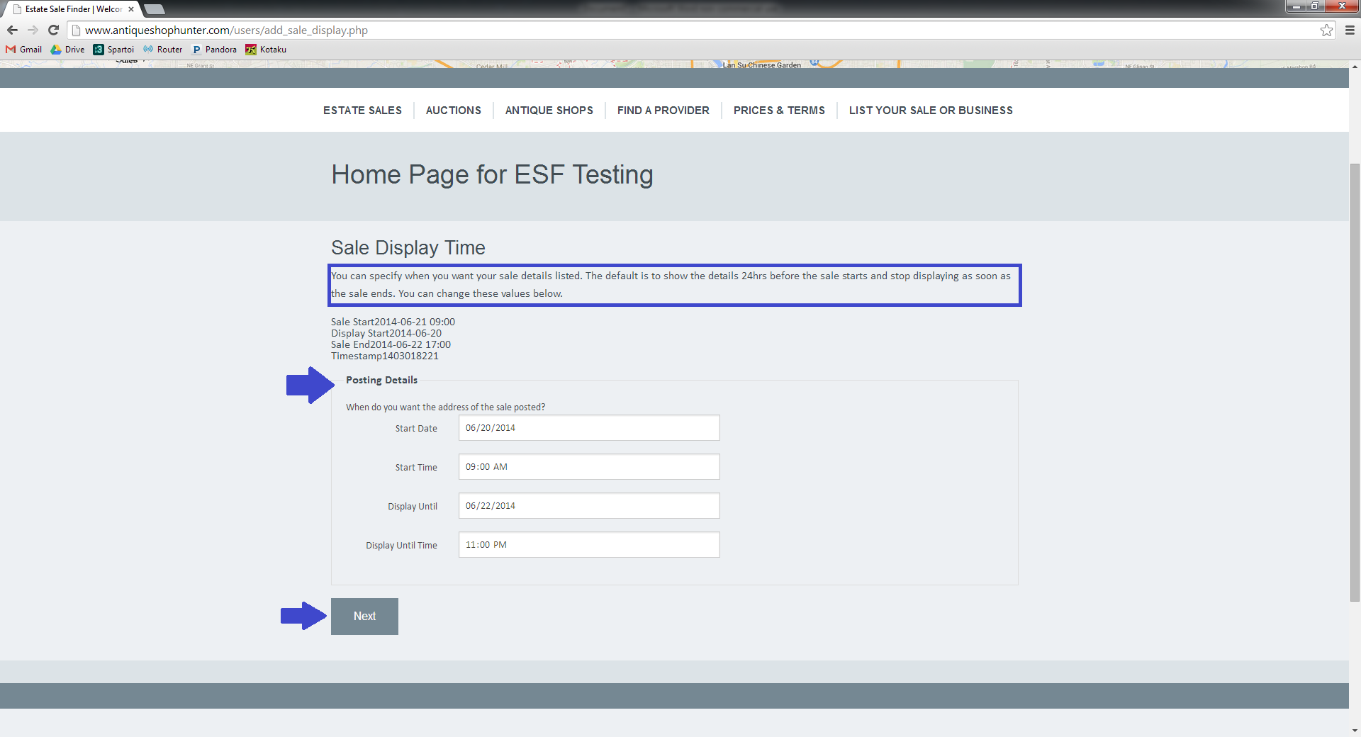
Once you’ve entered your desired dates and times, click the next button. 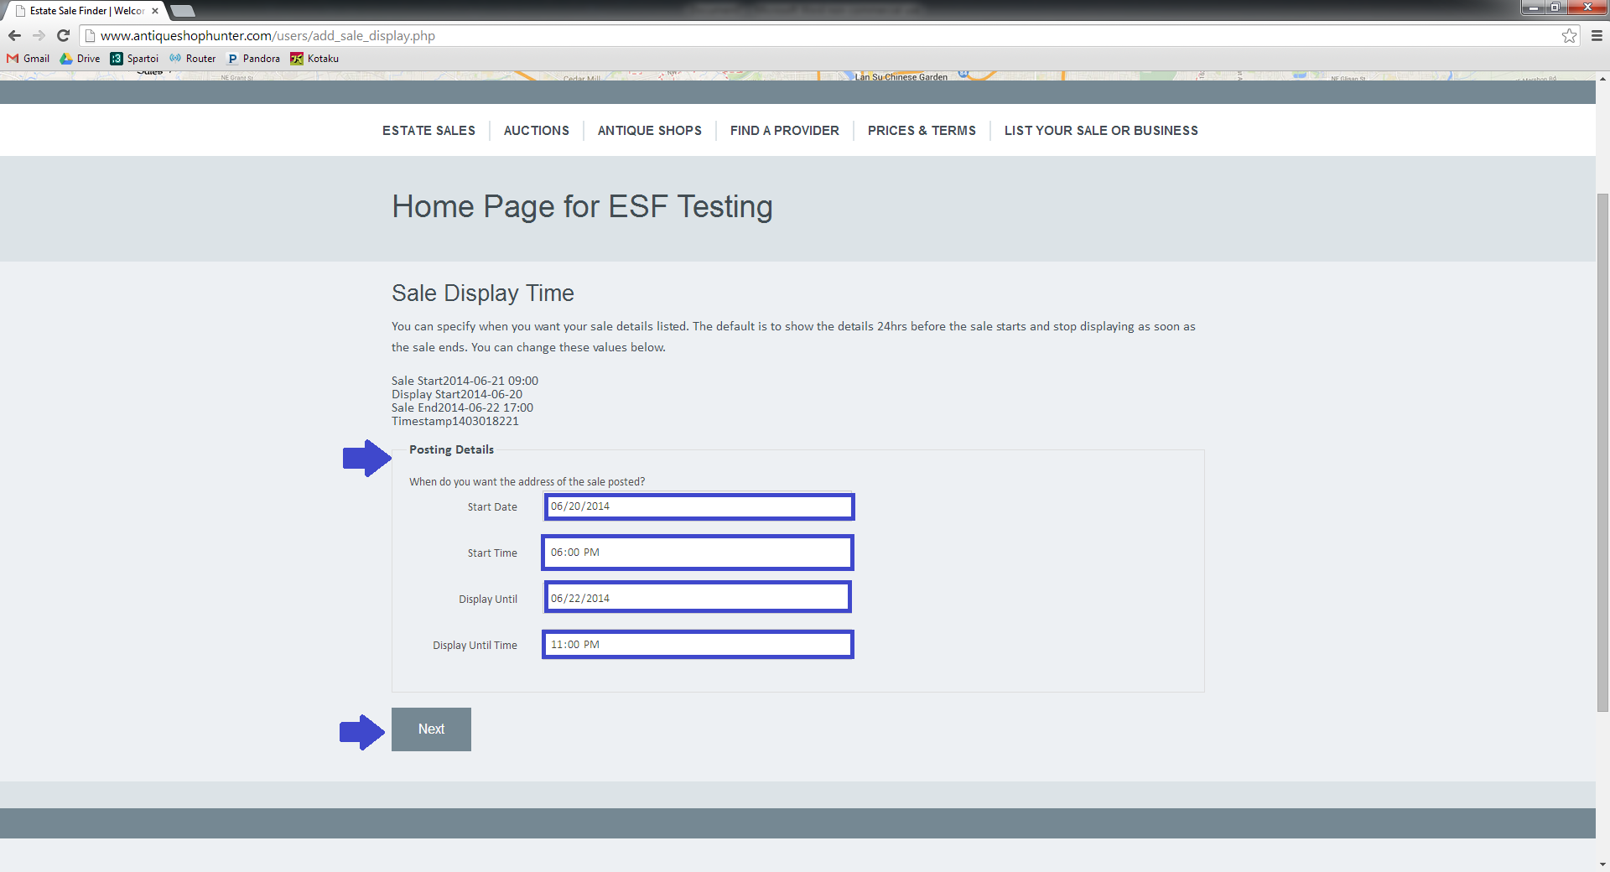

If you do not have photos, you’re done! Simply navigate away from the page.
If you have photos to add to your sale, this page is where you’ll do so. Click on the ‘Choose Files” button.
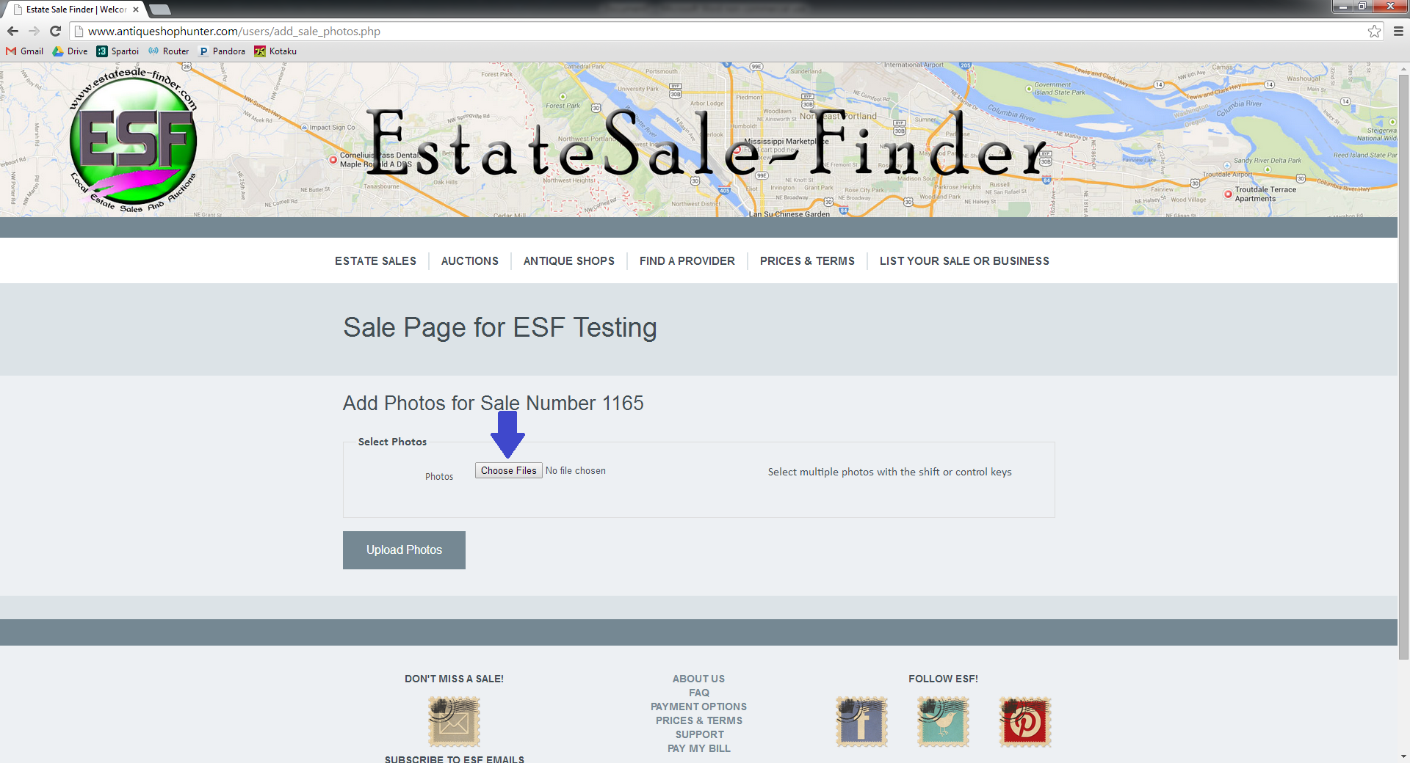

You’ll now have access to the files that are on your computer or attached memory device such as a phone, camera, or external hard drive.
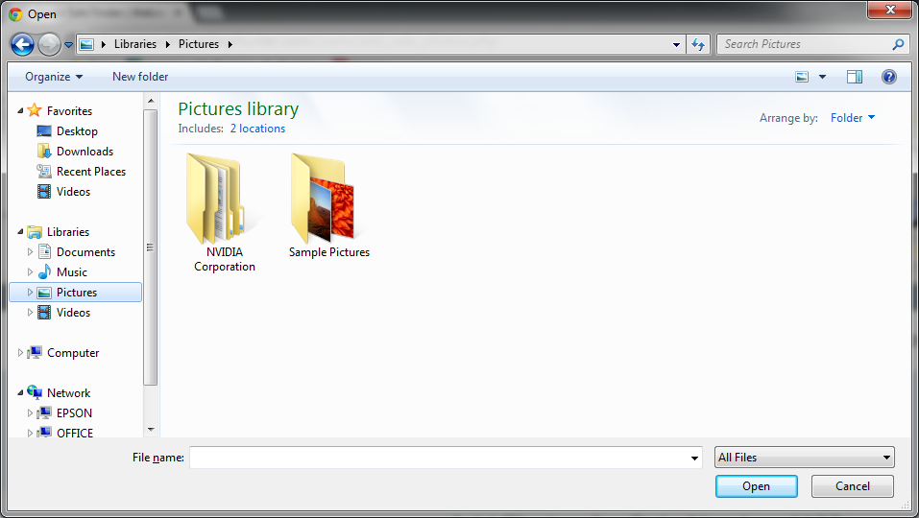

Navigate, as you normally would, to the location of your photo files. You can use the shift and ctrl keys to choose multiple files at one time.
To select a range of files, click on the first file, then hold the shift key and select the last file. This will capture all images in between.
If you want to pick and choose without selecting a range, hold down the control key and click on each photo that you’d like to add.
You’ll see the list of selected files in the ‘File Name’ field.
When you’ve selected all your photos, click ‘open.’
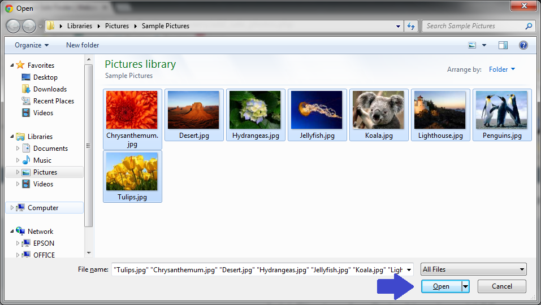

You can see that you’re back on the photo upload page. The photo uploader has detected that 8 photos were selected to add to this sale.
Click ‘Upload Photos.”
It will take a moment to upload the image files. The upload status is visible in the bottom left hand corner of your browser window.
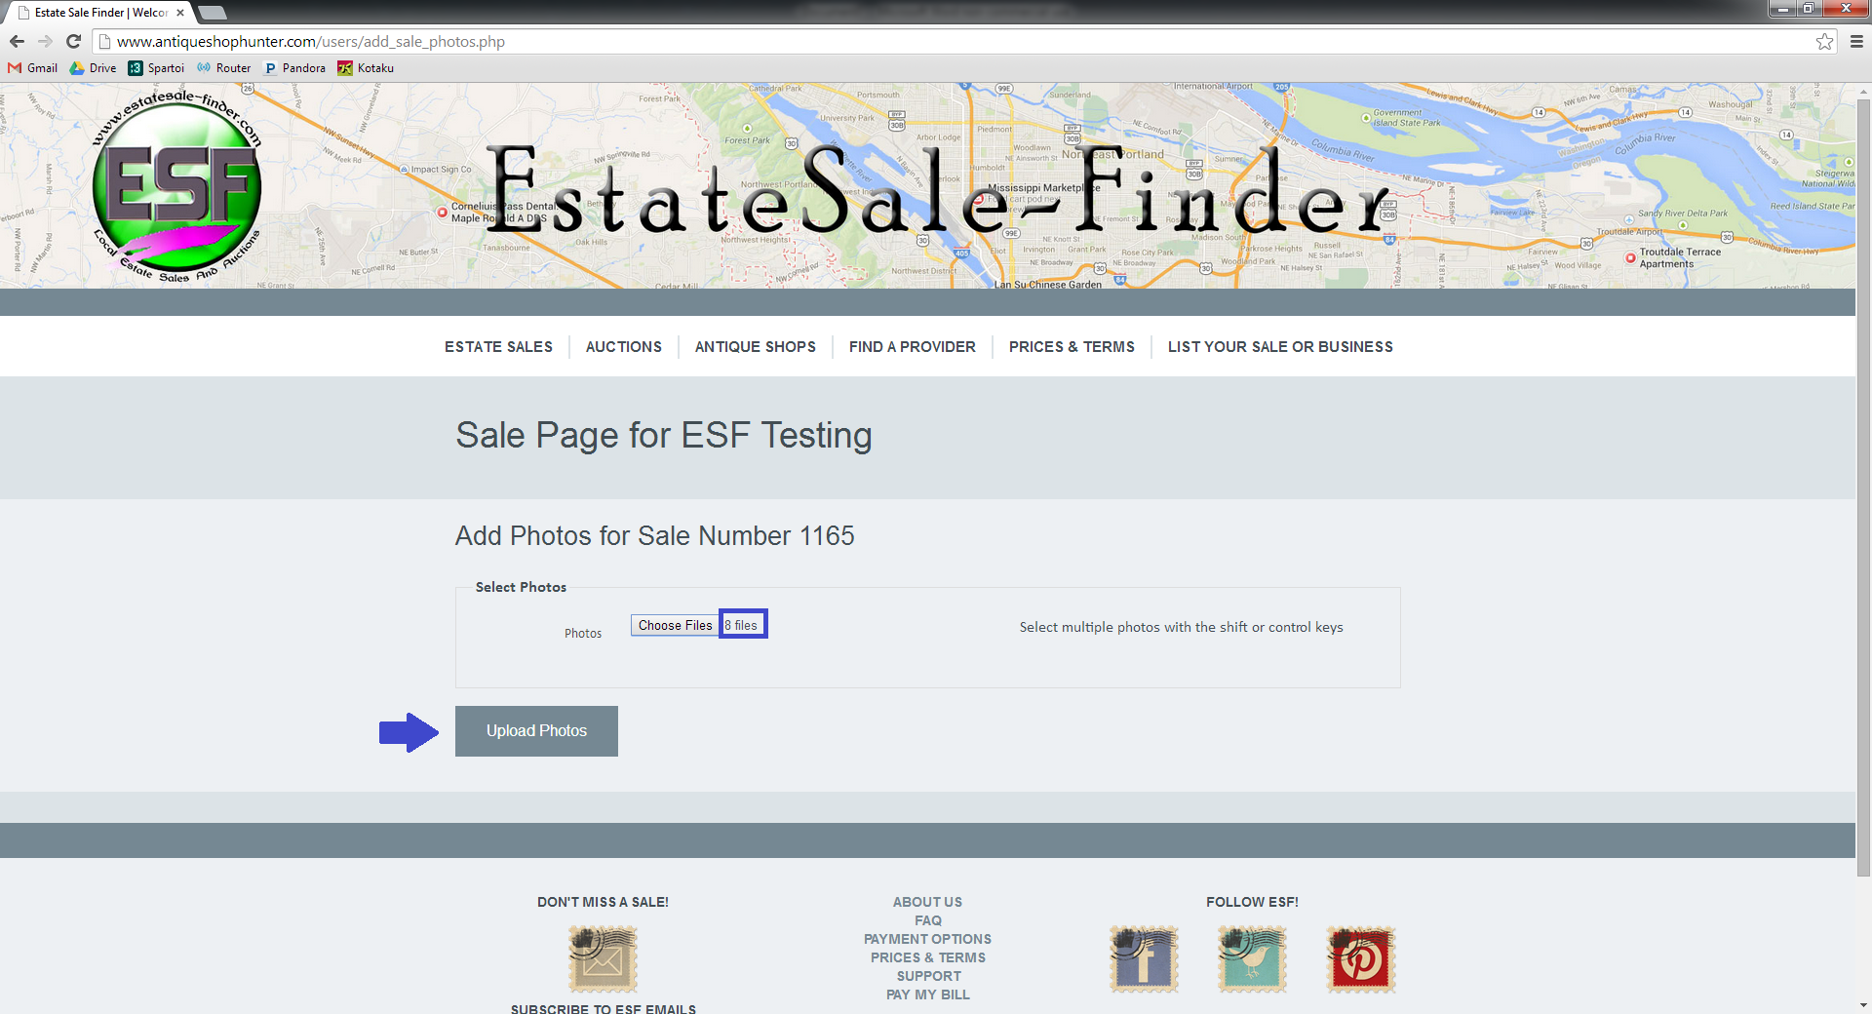

When the photos are finished uploading, you’ll be redirected to the sale page. You can see all the sale information displayed here, as well as your images.
If you’d like to remove photos, simply click on the red ‘x’ button in the upper left corner of the image.

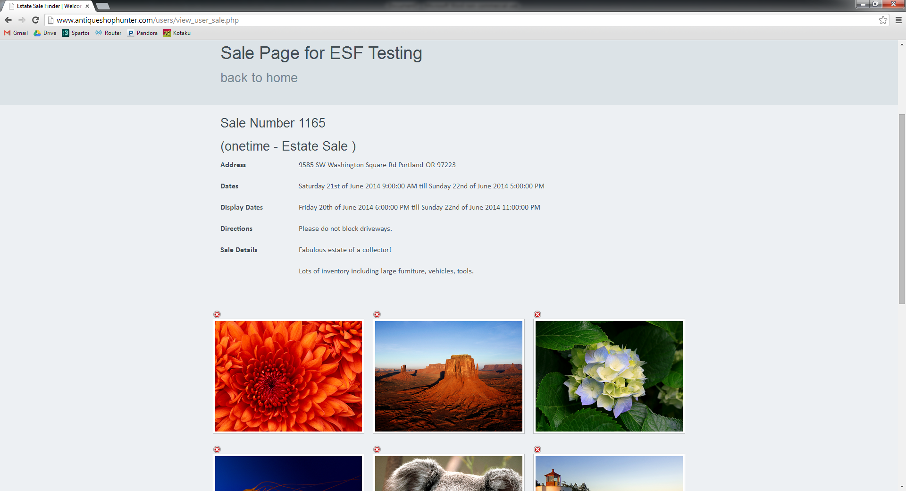

If you have more photos to add, click on ‘Add More Photos.’ If you are done, click on ‘My Homepage.’
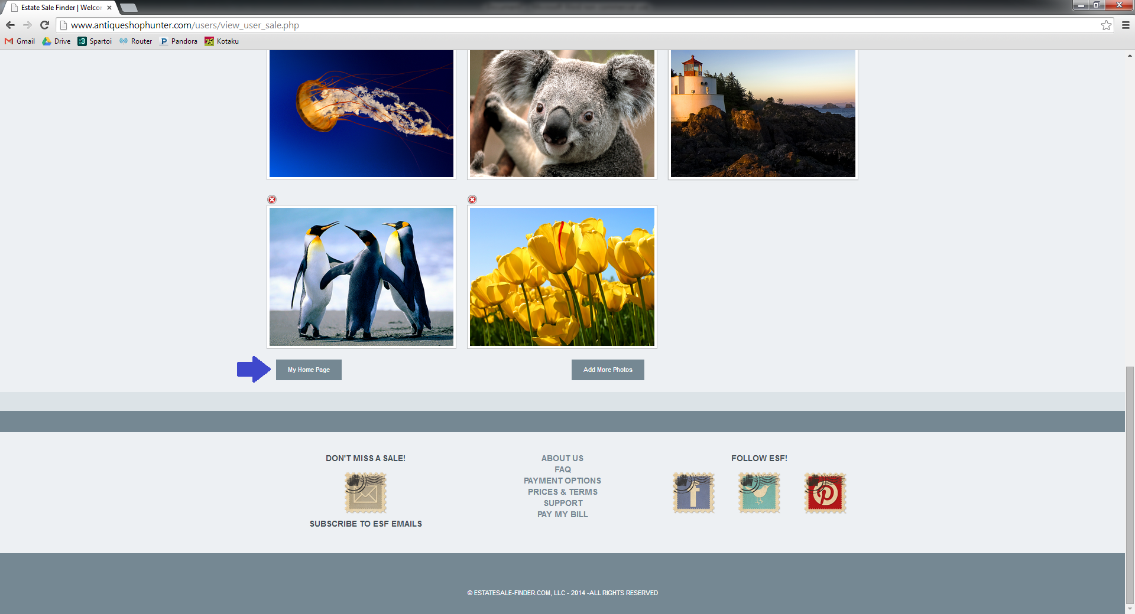

Back on the account homepage, you can see that the sale is listed under Upcoming Sales and that the user balance has been updated to reflect the $50.00 fee for this sale (remember, this account already had a $50.00 balance). You can now go to PayPal by clicking on the ‘Make a PayPal Payment’ button. You do not need a PayPal account to pay, you may do so with a credit or debit card without creating an account.
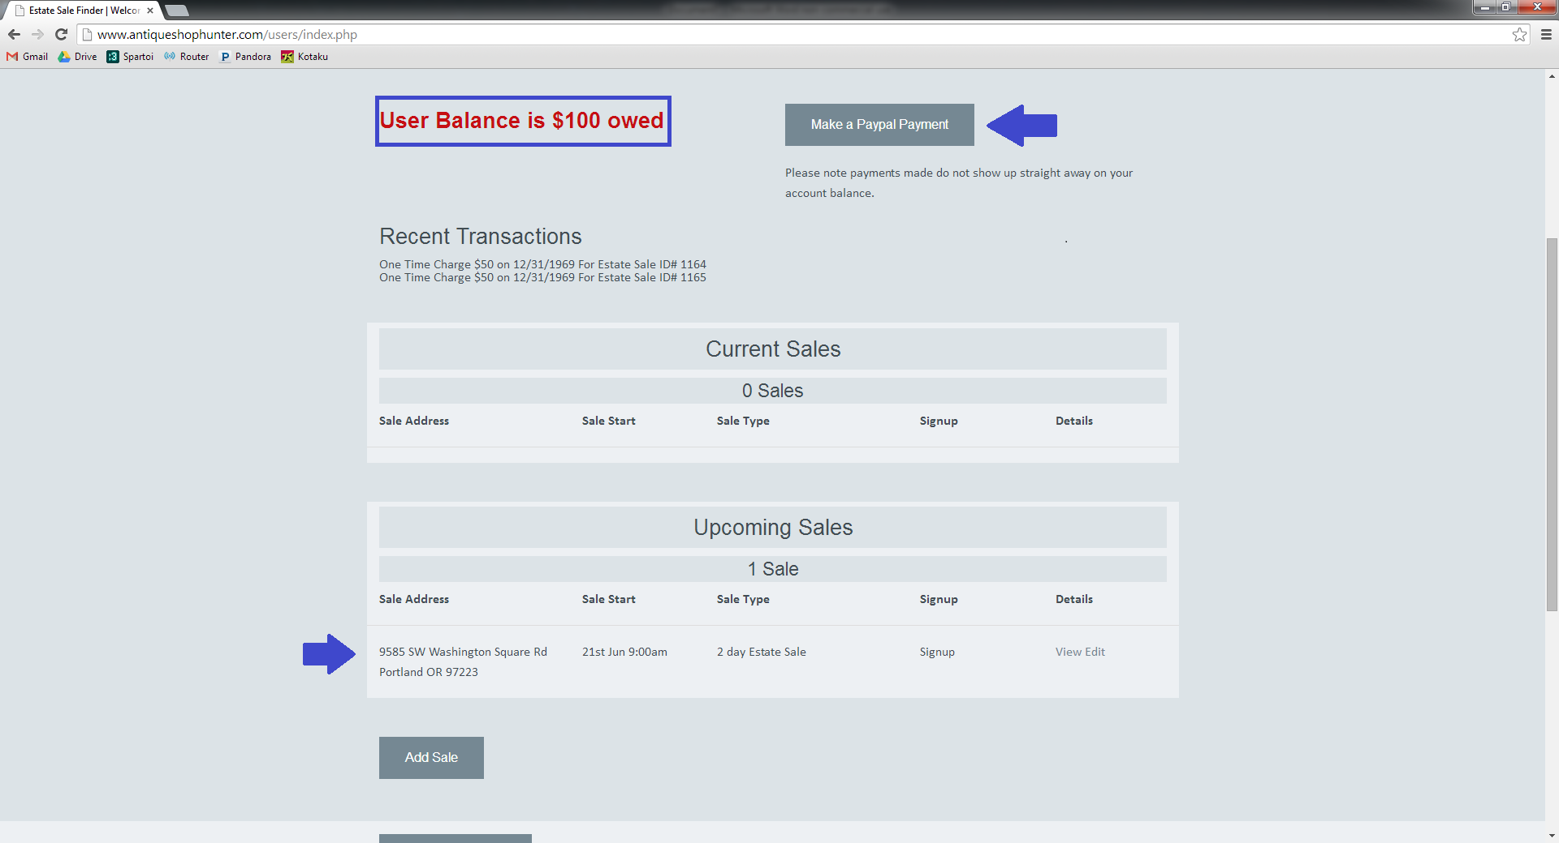

You can see that the vendor information for EstateSale-Finder is already populated. At this point, you may either log into your PayPal account or checkout as a guest without creating an account.
Once the payment process is complete, you can go back to EstateSale-Finder.
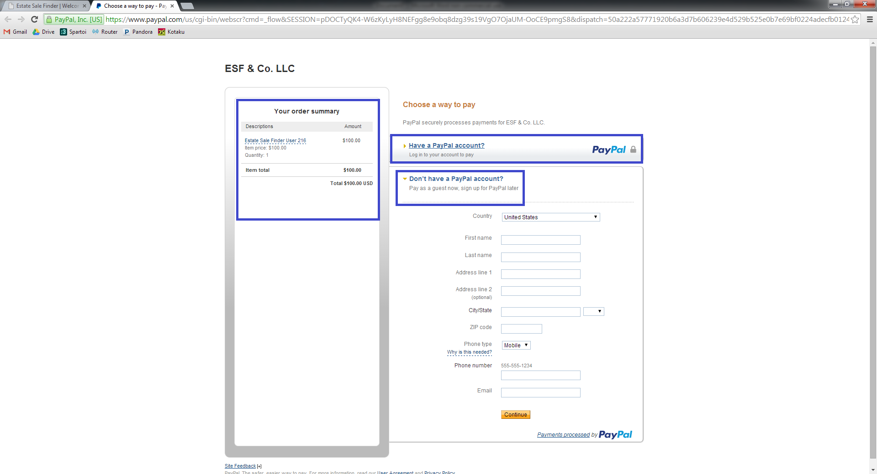

Under Estate Sales, you can see that this sale has been posted. The city, state, and zip code are provided. The street address is scheduled to be posted at a later date, so it displays as TBA.
The sale start date and type are also displayed, as well as the note that this sale has a signup. Shoppers can see all the sale details by selecting the ‘View’ hyperlink in the right column.
You’ve successfully posted this sale on ESF!
